**Location Recommendation for**

**Opening a Bubble Tea Shop in Great Detroit Area**

**Introduction**

One of the special drinks that Asians like to drink is bubble tea (https://en.wikipedia.org/wiki/Bubble_tea). Opening a Bubble Tea shop is relatively low cost compared to opening a restaurant. This report is to focus on the analysis to assist finding a good location to open a Bubble Tea shop in Metro Detroit area. For those who want to invest in Detroit area with Asian market and seek out small business ideas, this report can suggest potential location of a bubble tea shop with good competitive information.

According to the [2000 U.S. Census](https://en.wikipedia.org/wiki/2000_U.S._Census) there were 103,054 people of Asian origins living in the Detroit Metropolitan area. From 2000 to 2010 the Asian American population combined of Wayne, Oakland, and Macomb counties increased by 37%. As of 2010 almost half of the Asian Americans in the three county area live in Oakland County.

Earlier in 2018, a new Bubble Tea shop (Kung Fu Tea) opened in Oakland County. People have to wait in a long line to get their drinks during popular hours like weekend nights. Together with the increasing Asian population in Detroit area, this presents a great business opportunity.

**Data Section**

1. Foursquare bubble tea dataset (Blue dots): Getting all the current bubble tea shop locations and details via Foursquare API. With this dataset, use clustering analysis to get to the popular areas for the potential location. Using the details of the bubble tea shops to understand their ratings and popularity to optimize the model for location choice. We should open the shop close to low rating bubble tea shops, away from high rating ones. However, after initial data processing, there were only 4 out of 18 bubble tea shops had rating information. The Analysis will only focusing on the clustering, but not consider the quality of the shops.
2. Foursquare Chinese restaurants dataset (red dots): Getting all the current Chinese restaurants location data via Foursquare API. People can stop by the bubble tea shop before or after they have meals in these restaurants.
3. University dataset (Green Dots): getting University location and student population dataset by scraping the webpage: https://www.collegesimply.com/colleges-near/michigan/detroit/ University students are a big target who consume bubble tea. This can be another market together with the Asian market.

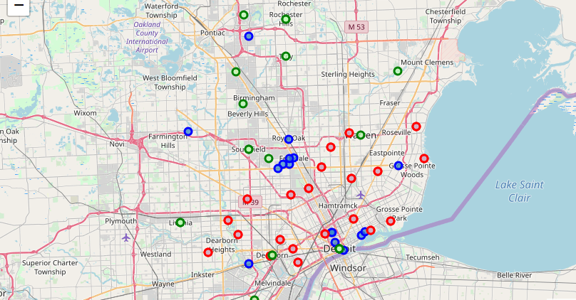

**Methodology**

Both the universities and the Chinese restaurants are representing where the consumers are. In order to give proper weights to the model, below are a few assumptions:

1. 10 % of university students are potential bubble tea drinkers.
2. Each Chinese restaurant is a small to media size restaurant with daily 200 customers.
3. 50% of Chinese restaurant customers are potential bubble tea drinkers

So the importance weighting for each:

University = population * 10%

Chinese restaurant = 200*50%=100

The bubble tea shops are the competitors. There are two location selection strategies: one is to open the new shop where the competitors are so the customers will see the new place and be willing to try it. The other strategy is to be away from the competitors. Both are analyzed in this report:

1. Among competitors

Using the K-means clustering analysis to find the clusters of current bubble tea shops.

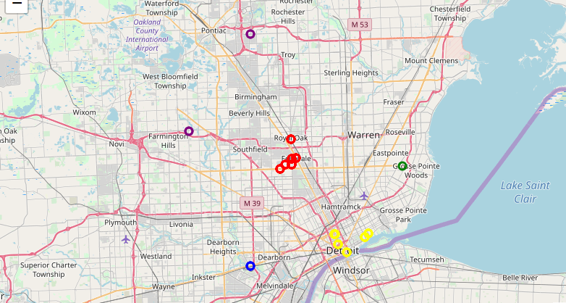

The two K means cluster centrals of the yellow and green groups are used to calculate the distances to all university and Chinese restaurants.

The final score of each location has positive correlation with importance, and negative correlation with distance. The formula is like below:

N is the total number of Chinese restaurants and Universities

1. Away from competitors

Similar to the first strategy, the final score of each location has positive correlation with importance of the Chinese Restaurants and the Universities, and negative correlation with their distances. It also has negative correlation with the importance of the competitors and positive correlation with the distance to the competitors.

In order to make the formula of #1 work for this strategy, the importance of the competitors are negative numbers. The assumption of the traffic to a Bubble Tea shop is daily 500. Will use this as the importance factor for competitors.

The formula is like below:

N is the total number of Chinese restaurants, Universities and Bubble Tea Shops.

Because the Great Detroit is such a big area, weighted K-Means clustering is used to find two centroids for the potential locations. The weights are based on the importance of each Chinese restaurant, university or competitor bubble tea shop.

**Results**

Results are discussed based on the two strategies above:

1. Among competitors

Detroit downtown location score = 2109

North location score = 1700

Based on the clustering analysis, both the downtown and north locations are good. The downtown location (Exact location is Eastern Market, downtown Detroit) has relatively more potential customers than the north location (Ferndale, MI). But both have very good traffic and young / Asian audience in the area.

1. Away from competitors

After running the clustering analysis, two clusters are shown below. The two centroids are:

1. Northfield Drive, Rochester Hills, Oakland County, Michigan, 48309, USA
2. Saint Phillips Missionary Baptist Church, Livernois Avenue, Detroit, Wayne County, Michigan, 48238, USA

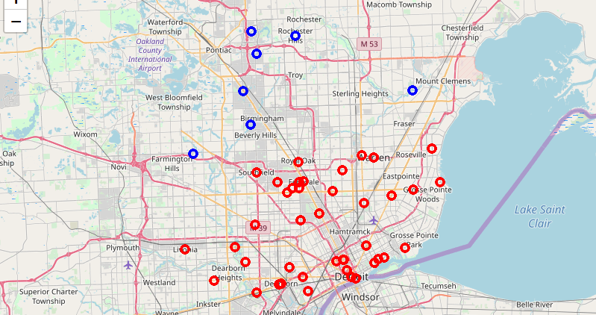

**Discussion**

1. From both strategies, one location will be downtown Detroit, another more on the northern side of the area. One very important factor that is not included in the analysis is the rent price for these different locations. This can be a decisive factor on where to open the new Bubble Tea shop.
2. With the second strategy of opening the bubble tea shop away from competitors, this analysis only discussed t clusters, there could be more clusters within the Great Detroit area.

**Conclusion**

According to models, the common location from both strategies is **downtown Detroit**. Then **Ferndale, MI** if the owner would like to take advantage the known reputation for special drinks like bubble tea in the area or **Rochester, MI** if the owner would like to own the entire market in that area are good options too.